
SRM Institute of Science and Technology
College of Engineering and Technology
DEPARTMENT OF ECE
SRM Nagar, Kattankulathur – 603203, Chengalpattu District, Tamilnadu
Academic Year: 2024-2025 (ODD)
Test: Assignment 1 Date:
Course Code & Title: 21ECE263T Micro, Nano Electromechanical Device Duration:
Year & Sem: IV & VII Max. Marks: 10

Course Articulation Matrix:

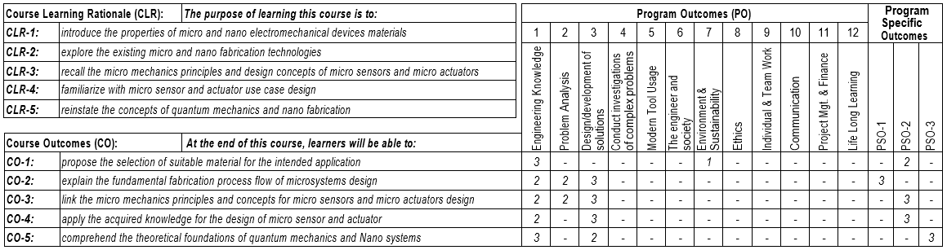

Answer 2 questions
(5x2) 10 Marks
Q. No | Questions | Marks | BL | CO | PO
 | Why SDN is preferred over Traditional network? | 5 | 1 | CO1 | 1
 | SDN architecture | 5 | 1 | CO1 | 1

